Daytime Running Lamps Control Function – CGEA1.3

Functional Description

This STSS handles the Daytime Running Lamps feature, which provides customers the choice to activate or deactivate the use of Daytime Running Lamps via the settings menu. The Instrument Cluster uses the Personalization signals for the Message Center function to set to enable or disable the Daytime Running Lamps feature in the BCM module.

Starting in MY2019 with U625/U611 the Settings are migrating from the cluster to Center stack. This STSS supports displaying settings in the cluster or configuring the cluster settings off if they are displayed in the Center stack.

The customer uses the message center switches and display to enable and/or change the Daytime Running Lamps settings in the vehicle.

Interfaces

Interface Context Diagram (I/O Block Diagram)
Figure 1 Daytime Running Lamps Function Context Diagram
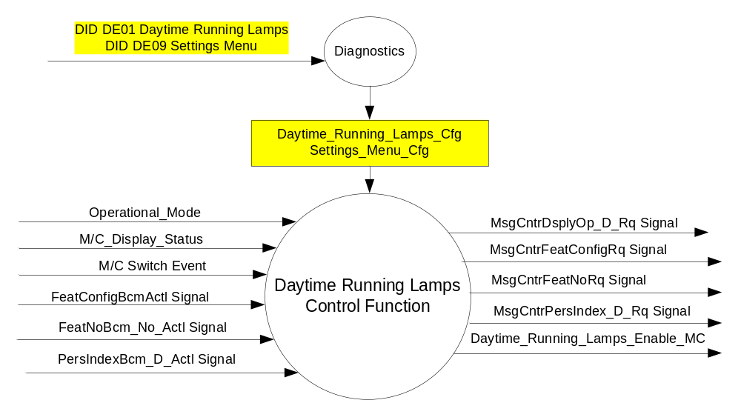

Inputs

- INTERNAL:
- Operational_Mode
- M/C Switch Event
- Daytime_Running_Lamps_Cfg
- Settings_Menu_Cfg
- M/C_Display_Status
- MUX message on the CAN Bus

- FeatConfigBcmActl Signal
Signal Name | Size (bits) | Detail | Units | Res. | Offset | State Encoded | Min | Max
FeatConfigBcmActl | 16 | - | Undefined | 1 | 0 |  | 0  (0x0) | 65535  (0xFFFF)

- FeatNoBcm_No_Actl Signal
Signal Name | Size (bits) | Detail | Units | Res. | Offset | State Encoded | Min | Max
FeatNoBcm_No_Actl | 16 | - | Number | 1 | 0 |  | 0  (0x0) | 65535  (0xFFFF)

- PersIndexBcm_D_Actl Signal
Signal Name | Size (bits) | Detail | Units | Res. | Offset | State Encoded | Min | Max
PersIndexBcm_D_Actl | 3 |  | SED | 1 | 0 |  | 0  (0x0) | 1  (0x7)
 |  | PERS_1 |  |  |  | 0 (0x0)
 |  | PERS_2 |  |  |  | 1 (0x1)
 |  | PERS_3 |  |  |  | 2 (0x2)
 |  | PERS_4 |  |  |  | 3 (0x3)
 |  | Vehicle |  |  |  | 4 (0x4)
 |  | Unused |  |  |  | 5(0x5)
 |  | Unused |  |  |  | 6 (0x6)
 |  | Unused |  |  |  | 7 (0x7)

Outputs
- Daytime_Running_Lamps_Enable_MC
- MUX message on the CAN Bus

- MsgCntrDsplyOp_D_Rq Signal
Signal Name | Size (bits) | Detail | Units | Res. | Offset | State Encoded | Min | Max
MsgCntrDsplyOp_D_Rq | 3 |  | SED | 1 | 0 |  | 0  (0x0) | 7  (0x7)
 |  | NULL |  |  |  | 0 (0x0)
 |  | QUERY |  |  |  | 1 (0x1)
 |  | SET |  |  |  | 2 (0x2)
 |  | UPLOAD |  |  |  | 3 (0x3)
 |  | RESTORE |  |  |  | 4 (0x4)
 |  | COPY |  |  |  | 5(0x5)
 |  | Not used |  |  |  | 6 (0x6)
 |  | Not Used |  |  |  | 7 (0x7)
.
- MsgCntrFeatConfigRq Signal
Signal Name | Size (bits) | Detail | Units | Res. | Offset | State Encoded | Min | Max
MsgCntrFeatConfigRq | 16 |  | Undefined | 1 | 0 |  | 0  (0x0) | 65535  (0xFFFF)

- MsgCntrFeatNoRq Signal
Signal Name | Size (bits) | Detail | Units | Res. | Offset | State Encoded | Min | Max
MsgCntrFeatNoRq | 16 |  | Number | 1 | 0 |  | 0  (0x0) | 65535  (0xFFFF)

- MsgCntrPersIndex_D_Rq
Signal Name | Size (bits) | Detail | Units | Res. | Offset | State Encoded | Min | Max
MsgCntrPersIndex_D_Rq | 3 |  | SED | 1 | 0 |  | 0  (0x0) | 7  (0x7)
 |  | PERS_1 |  |  |  | 0 (0x0)
 |  | PERS_2 |  |  |  | 1 (0x1)
 |  | PERS_3 |  |  |  | 2 (0x2)
 |  | PERS_4 |  |  |  | 3 (0x3)
 |  | Vehicle |  |  |  | 4 (0x4)
 |  | Not Used |  |  |  | 5 (0x5)
 |  | Not Used |  |  |  | 6 (0x6)
 |  | Not Used |  |  |  | 7 (0x7)

Function/Performance

Operational Modes

Mode | Differentiating Vehicle Conditions
Sleep Mode | Daytime Running Lamps Control Function Text Messages Disabled
Limiting Mode | Daytime Running Lamps Control Function Text Messages Disabled
Normal Mode | Daytime Running Lamps Control Function Text Messages Enabled / Disabled
Crank Mode | Daytime Running Lamps Control Function Text Message Enabled / Disabled

Voltage Levels

Refer to the Cluster Features table located in the Operational Modes and Voltage Range Strategies Section in this SPSS.

Human-Machine Interface

Visual

Indicator Graphics / Display Format
For program specific display, refer to “<Program> Cluster Menu Structure.xls” and Program VAPS Model.
Example Graphics
Level 2 | Level 3 | Level 4 | Level 5
Lighting > | # Daytime Running Lamps

Indicator Color Coordinates

Reference section COLOR & ILLUMINATION REQUIREMENTS (GRAPHICS)

Indicator Characteristics

Refer to Message Center X Display_Y Button Interface Section, where X and Y are appropriate values in this document.

Audio

None

Switch Control Logic

Consumer access to the Daytime Running Lamps Control Configuration shall be as specified in the message center basic functionality display as specified in Message Center X Display_Y Button Interface Section, where X and Y are appropriate values in this document.

System Accuracy

Within a 100msec of receiving a message that results in a change of state the cluster will update the display to the proper status.

Operation: Performance and Functional

Subsystem Algorithm Flowchart / State Diagram
Figure 2 Daytime Running Lamps Flowcharts
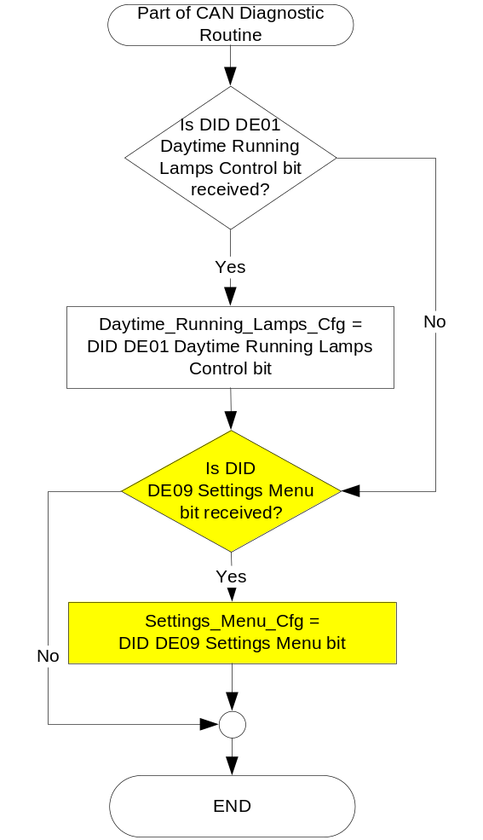

Figure 3: DRL input request Flowcharts

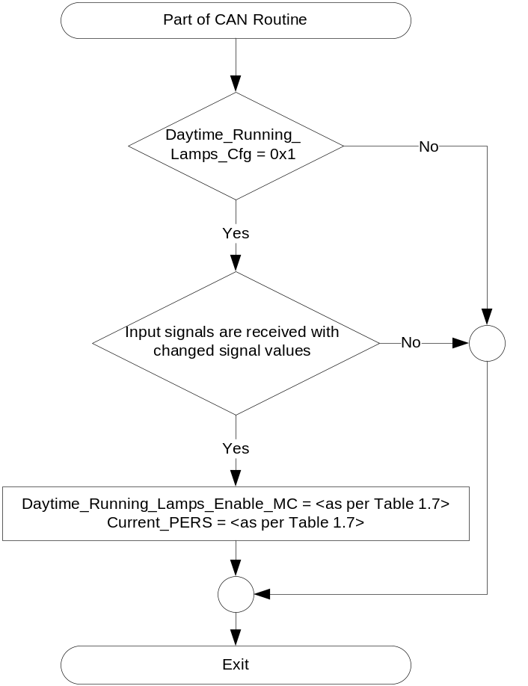

Figure 4: DRL output SET request Flowcharts

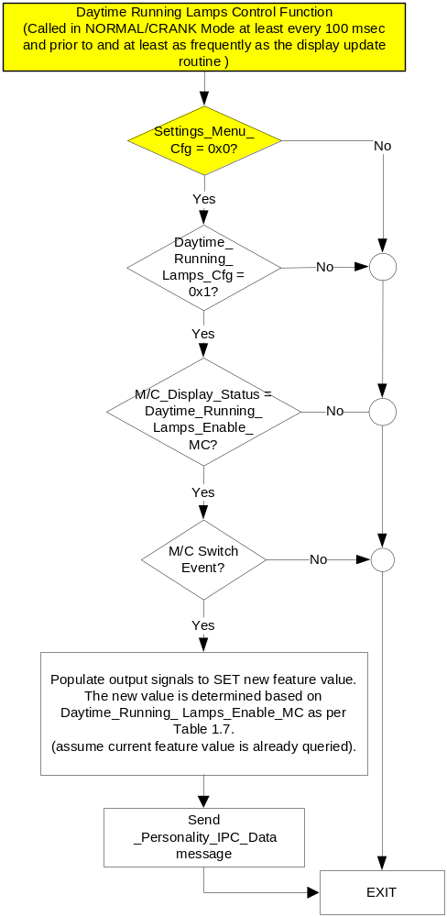

NOTE: In the Daytime Running Lamps Control Function Flowchart, the definition of "M/C Switch Event" is defined in Message Center X Display_Y Button Interface Section, where X and Y are appropriate values in this document.

Operation Description (supports algorithm flowchart /state diagram)

- Daytime_Running_Lamps_Enable_MC State Assignment
FeatNoBcm_No_Actl | FeatConfigBcmActl | Daytime_Running_Lamps_Enable_MC | Current_PERS ⁽³⁾
0x0415 ⁽¹⁾ | Disable  (0x00) | Disable  (0x0) | 0x0 – 0x4
0x0415 ⁽¹⁾ | Enable  (0x01) | Enable  (0x1) | 0x0 – 0x4
0x0415 ⁽¹⁾ | Other ⁽²⁾ | Error  (0x2) | Last Known
Missing per Section 1.4.1 ⁽²⁾ |  | Error  (0x2) | Last Known
⁽¹⁾ Daytime Running Lamps Enable Feature Number. Reference is Feat Num table in “Vehicle Personalization FS”
⁽²⁾ Message Response is Faulted (0x2 – 0xFFFF)
⁽³⁾ Equal to the received “PersIndex<--->” signal value . When faulted Keep last known value.

- MC Daytime Running Lamps Request Messages based upon Daytime_Running_Lamps_Enable_MC
Daytime_  Running_  Lamps_  Enable_MC | Display Menu | 5-Button Switch Selection Event | MsgCntrDsplyOp_D_Rq  Signal | MsgCntrFeatNoRq  Signal | MsgCntrFeatConfigRq  Signal | MsgCntrPersIndex_D_Rq  Signal
Disable  (0x0) |  Off   On | Up/Down + OK (Select On) | SET (0x2) | 0x0415 | 0x01 (Enabled) | Current_PERS
Enable  (0x1) |  Off   On | Up/Down + OK (Select Off) | SET (0x2) | 0x0415 | 0x00 (Disabled) | Current_PERS
Error  (0x2) |  Off   On | Up/Down + OK (Select Off or On) | SET (0x2) | 0x0415 | 0x00 (if Off is selected)  0x01 (if On is selected) | Current_PERS

- Personalization Features for Daytime Running Lamps
Feature Name | Feature Num | Cfg Num | Cfg Value
Daytime Running Lamps | 0x0415 | 0x01 | Enable
Daytime Running Lamps | 0x0415 | 0x00 | Disabled

Function Safety Classification (EMC)

Class B

Memory Storage

Parameter Name | Description | Value at  Battery Connect | Value at  Module Wake-up
Daytime_Running_Lamps_Enable_MC | Output displayed in the M/C | Enabled (0x1) | Do Not Init
MsgCntrDsplyOp_D_Rq Signal | Output Signal to indicate Request Type. | NULL (0x0) | Do Not Init
MsgCntrFeatNoRq Signal | Output Signal to indicate Feature Number. | (0x0000) | Do Not Init
MsgCntrFeatConfigRq Signal | Output Signal to Specify the desired feature Value. | (0x0000) | Do Not Init
MsgCntrPersIndex_D_Rq Signal | Output Signal to indicate which personality profile is being accessed. | Vehicle (0x4) | Do Not Init
FeatNoBcm_No_Actl Signal | Input signal sent from the BCM to indicate Feature Number. | (0x0000) | Do Not Init
FeatConfigBcmActl Signal | Input signal sent from the BCM to indicate current value of the feature setting for the feature that is being set or queried. | (0x0000) | Do Not Init
Daytime_Running_Lamps_Cfg | Configures cluster to allow Daytime Running Lamps. Set to Disabled at Cluster Supplier Manufacturing Plant. | Use Stored Value | Use Stored Value
Settings_Menu_Cfg | Configures cluster to display items in the Settings menu (Set to “cluster” at cluster supplier manufacturer plant) | Use Stored Value | Use Stored Value
M/C_Display_Status | State Indicator to identify which text is currently being displayed on Message Center display. See * | See * below | See * below
M/C Switch Event | Event that is indicated as per the switch interface for the Message Center. See * | See * below | See * below
Operational_Mode | 4 state indicator for cluster operational mode | Limited | Limited, Normal or Crank

* Refer to Message Center X Display_Y Button Interface Section, where X and Y are appropriate values in this document.

Reconfigurable Telltale

Not Applicable

Prove Out

Not applicable

Message Center Msg

Message IDs to be assigned.

Error Handling

Missing Message Strategy

The signals will be declared missing as per the Diagnostics section of this SPSS.

DTCs states and history will be determined as per the Diagnostics section of this SPSS.

If Daytime_Running_Lamps_Cfg = Disabled, the cluster shall never log a missing message for this feature.

Diagnostics

Self Test

None

Engineering Test Mode

Reference section “Dealer / Engineering Test Mode (ETM)”

Part II Performance

Supported Diagnostic Trouble Codes (DTCs)
DTC | Description
C14000 | Loss of Communication with BCM

DID DExx:
Block  Num | Block Description | Byte(s) | Bits | State: Description | "0" | "1" | Default | Comments/  Information
PACKETED BLOCKS
$01 | Option Content (B&A) | * | * | Daytime Running Lamps Control Function | Disabled | Enabled | Enabled | ***REGULATORY***  This parameter allows the Daytime Running Lamp settings menu to be displayed in the cluster. It can be over-ridden by the Settings Menu config.
$09 | Option Content (B&A) | * | * | Settings Menu | Cluster | Center Stack | Cluster | This parameter allows the Settings menu to be displayed in the cluster when 0x0. When 0x1, the expectation is that settings are displayed in the Centerstack. For this feature (when 0x1), the cluster will remove almost all items from settings menu. (Cluster display choices remain). Note this is a global config, each feature still has its own config for presence on vehicle.
*Byte and bit location to be identified in Part II Specification for this cluster

Reference Specification

None.

Revision History
SPSS Module Revision History
Revision Level | Name | Change Description | Date
1.0 | J. Gregoire  S. Watkins | Initial Release. Feature Owner: Patrick Holub. BCM lead is Neal Manson. | 8/29/2012
1.1 | S. Watkins  M. Hakim | Minor update to resolve an open issue. Also to update diagnostic DID to $DExx :  Section 1.3.5.4: Memory Storage table: Corrected typo for FeatNoHcm_No_Actl Signal and FeatConfigHcmActl Signal, sent from HCM to be FeatNoBcm_No_Actl Signal and FeatConfigBcmActl Signal, sent from the BCM  Updated diagnostic DID $DE00 to $DExx throughout the document.  Added CGEA1.3 to the document footer. | 9/4/2013
2.0 | S. Watkins | Starting in MY2019 with U625/U611 the Settings are migrating from the cluster to Centerstack. This STSS update is to support this effort. A configuration is added to ensure backward compatiblity.  Changes shown in yellow:  - Section 1.1 – Updated description to mention Center Stack  - Section 1.2.1, Figure 1 – Added DE09 Settings Menu  - Section 1.2.2 – Added Settings_Menu_Cfg  - Section 1.3.5.1, Figure 2 – Added DE09 Settings Menu  - Section 1.3.5.1, Figure 4 – Added decision box for Settings_Menu_Cfg and also added “Crank” to first box (defect fix unrelated to other changes).  - Section 1.3.5.4 – Added Settings_Menu_Cfg  - Section 1.5.3 – Added Settings Menu to DE09 | 1/8/2017

